Side Entry Category 6A Shielded Keystone Jack

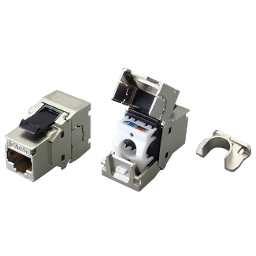

6A shielded keystone jack supports the 10/100/1G BASE-T Ethernet, as well as advanced new 10G BASE-T Ethernet. The shielded jack with industrial leading transmission performance and provide exceptional levels of headroom, meets and exceeds ANSI/TIA-568.2-D and ISO/IEC 11801 2nd edition Category 6A Class EA standards. Zinc-alloy metal shell balances/eliminates the Alien crosstalk while the data is at high speed transmission. Knock-out design provides optimal options for cable coming from side end and prevent to bend cable in trunking with limit space to retain installation performance.

Features

Zinc-alloy metal shell

Knock-out design to allow side entry of cable

Half U (0.5U) system compatible

Tool-free, no additional tool required for termination

Contacts are phosphor bronze plated with 50 micro inches hard gold

Dual T568A &amp; T568B wiring

Polycarbonate 94V0 rated

4PPoE compliant in accordance with IEEE802.bt Type 4

Ordering Information

|  |  |
| --- | --- |
| PART | Description |
| 1A68TPZA1 | RJ45, 8-Conductor Cat.6A , Tool-free, Shielded, 180 degree, side entry |
| 1C68TPZA1 | RJ45, 8-Conductor Cat.6A , Tool-free, Shielded, 180 degree, side entry |